**CS5338 – Formal Languages**

**Spring 2019 – Assignment 1**

**Due: February 8, 2019**

Submitted by: Ahmed Raza ID: A04775175

1. Write regular expressions for the following languages over the alphabet å= {0, 1}:
   1. All strings that do not end with 00.

∑+0+1+(0+1)*(01+10+11)

* 1. All strings that contain an even number of 1’s.

0*(10*10*)*

* 1. All strings which do not contain the substring 10.

0*1*

1. Draw DFAs for each of the languages from question 1. None of your DFAs may contain more than 4 states.
2. 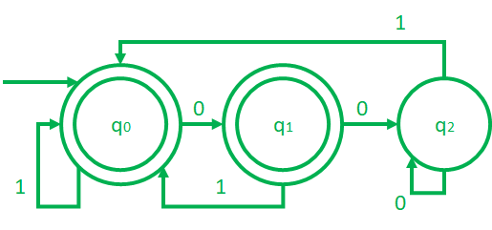
3. 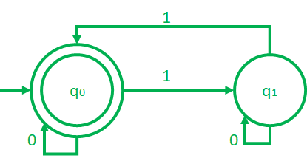
4. 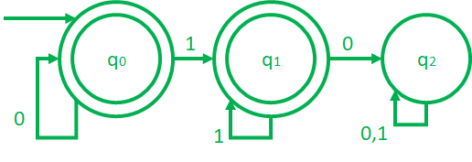

1. Write the DFAs tuples {Q, ∑, q0, F, δ} and define each symbol for DFAs from question 2. Provide transition table. Refer to slide # 8 from Chapter 2 slides.
2. Q={q0,q1,q2}

∑={0,1}

q0={q0}

F={q2}

δ{q0,0}=q1

δ{ q0,1}=q0

δ{ q1,0}=q2

δ{ q1,1}=q0

δ{ q2,0}=q1

δ{ q2,1}=q0

1. Q={q0,q1}

∑={0,1}

q0={q0}

F={q1}

δ{q0,0}=q0

δ{ q0,1}=q1

δ{ q1,0}=q1

δ{ q1,1}=q0

1. Q={q0,q1,q2}

∑={0,1}

q0={q0}

F={q2}

δ{q0,0}=q0

δ{ q0,1}=q1

δ{ q1,0}=q2

δ{ q1,1}=q1

δ{ q2,0}=q2

δ{ q2,1}=q2

1. Draw NFAs for each in question 1.
2. 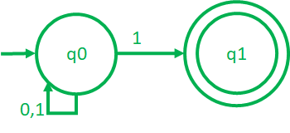
3. 
4. 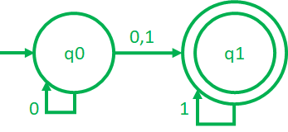

1. Which languages in question 1 accept these strings? Show the work.

* + 1. 001101
  1. 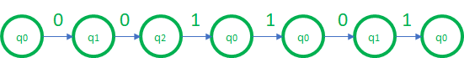

accepted

* 1. 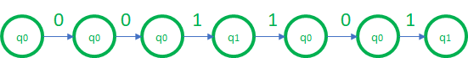

Not a final state, Not accepted

* 1. 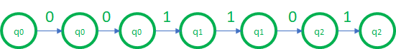

Not a final state, Not accepted

* + 1. 0101010100
  1. 

Not a final state, Not accepted

* 1. 

accepted

* 1. 

Not a final state, Not accepted

* + 1. 00111111
  1. 

accepted

* 1. 

accepted

* 1. 

Accepted

* + 1. 1111000110
  1. 

accepted

* 1. 

accepted

* 1. 

Accepted

* + 1. 00001111
  1. 

accepted

* 1. 

accepted

* 1. 

accepted

Note: Submit your answers to TRACS. No hard copies.